*Sent to all Members*

March 16, 2025  
  
Dear {%FName%},

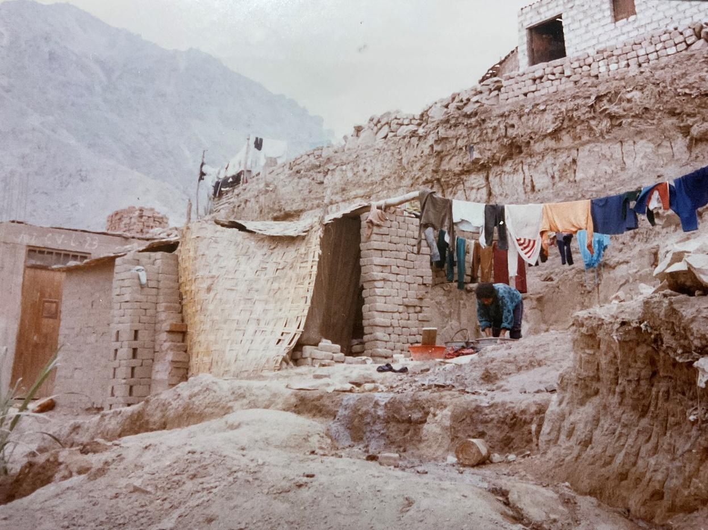

THE FACE FOR ME OF THE US AGENCY FOR INTERNATIONAL DEVELOPMENT

More than thirty years ago I lived in this shanty town outside Lima, Peru. Each day I walked by this “home” on my way to one of several soup kitchens operated by the Catholic parish for which I volunteered.

Two warm meals a day were made possible by food supplied by the Agency for International Development. We also operated a small pharmacy that made available the life-saving medications needed by the poorest of the poor, all provided through AID.

This experience during my years in Lima made me proud of the U.S. government and the Norbertine priests I lived with who articulated a preferential option for the poor.

My life-changing experience in Peru is only rivaled by my pride in Rotary for coming so close to eradicating polio throughout the world.

Today, however, my pride in the U.S. government is diminished. Draconian budget cuts to the Agency for International Development will cost lives. And the reduction in funding to the National Institute of Health will put children at risk of contracting polio just as it was close to eradication. The state of Wisconsin alone is losing more than 600 million dollars in NIH funding.

Those of us in the United States will soon be dealing with the more than 240,000 Ukrainian refugees living here on temporary humanitarian visas that were rescinded en masse last week. I personally know Ukrainians in Wausau whose home cities are now under Russian control. Their families have been evicted and homes have been confiscated, sold to Russian citizens. One implication is that many of the 240,000 Ukrainians in the United States have nowhere to go. But go they must.

What is the responsible response to these program cuts and rescinded visas?

Rotary International is providing answers. Learn what RI is doing to continue the eradication of polio and what the District 6220 Ukraine Relief Committee is doing here in Wisconsin and Michigan by attending TriCon April 25th and 26th in Brookfield, WI. How Rotary’s seven areas of focus will be addressed in the midst of this change will be on agendas at TriCon also.

An application for a matching $200 grant to attend is attached. Any member of Rotary in our district is welcomed and encouraged to apply.

[TriCon Matching Grant Application](https://www.dacdb.com/Rotary/Accounts/6220/Downloads/0/TriCon%202025%20Matching%20Grant%20App.docx)

These recent events call us to engage. Let us show those in need that the best days of Rotary International are ahead of us.

Thank you.

ROGER UTNEHMER  
Rotary District 6220  
District Governor 2024-25  
(C) 920 495 9677